Student Created WBL Projects 
* Purpose: for the student to create their own WBL.
Step 1: Go to Accounts Tab and under accounts you will click on “Add/Manage Student Project Groups”


Step 2: WBL Experience Manager, click “Add New”
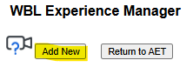
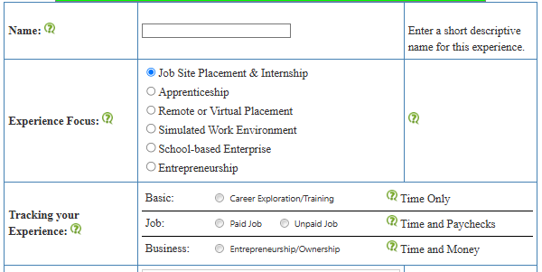
Step 3: Create the WBL
- Name: (give the project a name)
- Experience Focus:
(select the type of WBL)
- Tracking your Experience:
(what kind of records should you keep)
- Teacher Supervisor: (school supervisor/teacher)
- External Supervisor/Employer: (you can connect with employers here)
- Primary and Secondary Experience: (chose what type of experience matches the WBL)

Step 4: Hit “Save”
*If you ever need to edit your project click to make changes.

